When it comes to successful transition of community college students with disabilities to their post-graduation goals, it’s important to have a solid support system in place. Our study aims to enhance student success by implementing a triad model of support. 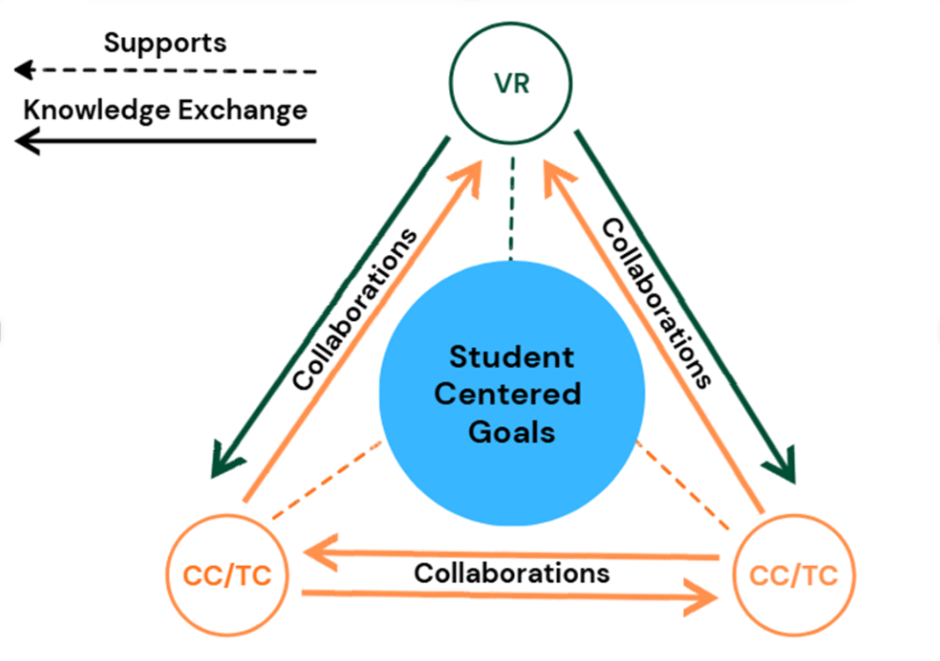
In our model, the triad consists of three members; two (2) community college staff or faculty, and one (1) vocational rehabilitation professional. These three members support not only each other, but maintain focus on the student/client with disabilities and their goals. This is called person-centered care, and it is important because there is strong evidence of the practice’s positive effects on job performance and satisfaction (Yun & Choi, 2019). While supporting the student, the community college staff and vocational rehabilitation professional are exchanging knowledge and resources with one another. This not only better supports the student’s goals, but creates stronger relationships between the support workers themselves!
Sources Cited:

Yun, D., & Choi, J. (2019). Person-centered rehabilitation care and outcomes: A systematic literature review. International journal of nursing studies, 93, 74-83.

The contents of this infographic were developed under a grant from the National Institute on Disability, Independent Living, and Rehabilitation Research (NIDILRR grant number #90RTEM0013).
For more on this topic, view the research study webpage: https://idd.vcurrtc.org/research/rs4.cfm

